HealthLink API Gateway

Tech Stack & Features
Cambio’s Tech | Implementation in Project
Java/Spring Boot | Core API gateway routing requests to microservices.
PostgreSQL | Stores API client credentials, rate-limiting logs.
Kubernetes | Deploy gateway + microservices (Helm charts included).
OAuth 2.0/JWT | Secure APIs using Keycloak (role-based access for doctors/patients).
HL7 FHIR | FHIR validator microservice (ensures incoming data is FHIR-compliant).
Kafka | Stream API access logs for real-time monitoring.
Prometheus/Grafana | Monitor API latency, error rates.
GitLab CI/CD | Auto-deploy to K8s on Git push.

Key Features
- Dynamic API Routing
  - Routes requests to backend services (e.g., /patients → Patient Service).
  - Uses Spring Cloud Gateway.
- FHIR Validation
  - Microservice that validates incoming JSON/XML against FHIR schemas.
  - Example: Reject non-compliant Patient resources.
- Real-Time Analytics
  - Kafka streams API logs to:
    - Fraud detection (alert on unusual spikes in requests).
    - Usage analytics (Grafana dashboard).
- Zero-Trust Security
  - OAuth 2.0 with JWT claims (e.g., "role": "doctor").
  - PostgreSQL row-level security for client credentials.
- Auto-Scaling
  - K8s Horizontal Pod Autoscaler (HPA) scales gateway pods under load.

Functional Requirement
- We need to share patient records with labs, pharmacies, and other clinics without exposing sensitive data
Ex:
- A lab should receive only test results, not full medical history
- Patients should approve data sharing via consent forms

- The system must accept and send data in HL7 FHIR format to work with our EHR (Electronic Health Record) systems.
Ex:
- import/export patient records as FHIR Patient or Observation resources

- We need instant notifications for critical events (e.g., abnormal test results, appointment changes)
Ex:
- SMS/email alerts when a lab result is ready

- Doctors, nurses, and patients should have different levels of access
Ex:
- Doctors → Can edit prescriptions
- Patients → Can only view their own records

- We must track who accessed/modified patient data for compliance (HIPAA/GDPR).
Ex:
- Logs showing "Dr. Smith viewed Patient X’s records on Jan 5.

Non-Functional Requirements
A. High Availability
- Requirement: *"The system must be available 24/7, even during peak hours."*
- Example:
  - Auto-scaling to handle 10,000+ requests per minute.
B. Fast Response Times
- Requirement: "API calls should respond in <1 second for 95% of requests."
C. Data Protection
- Requirement: "All data must be encrypted (at rest and in transit)."
D. Easy Integration
- Requirement: "Must work with existing hospital systems (e.g., Epic, Cerner)."

Example User Stories (For Agile Development)
- "As a doctor, I want to fetch patient records via FHIR API so I can avoid manual entry."
- "As a patient, I want to approve data sharing via a mobile app so I control my privacy."
- "As a system admin, I want to see who accessed patient data for compliance reports."

Architectural Diagram
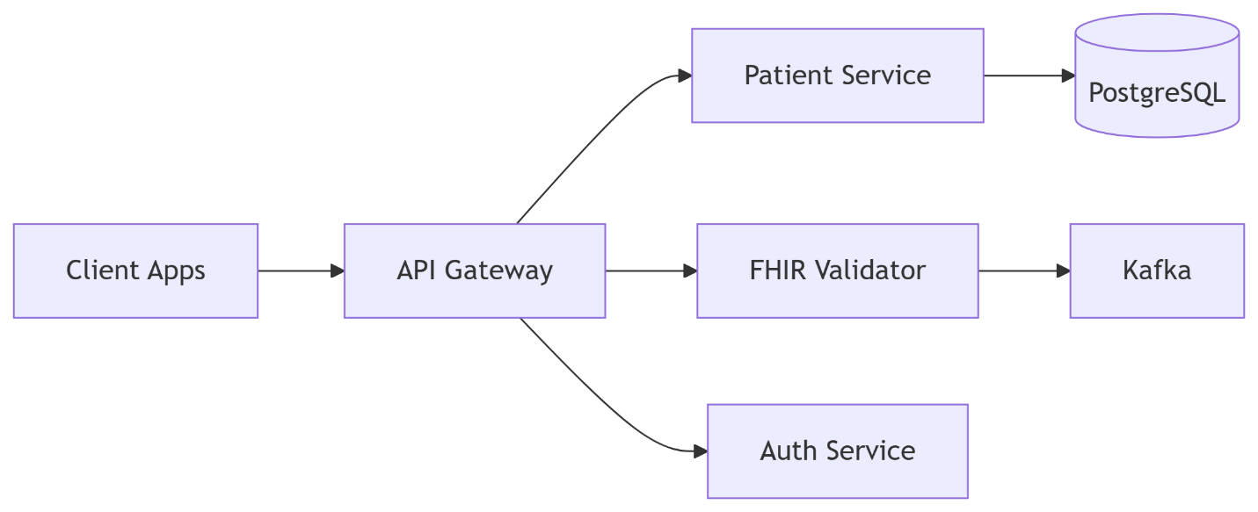

Database Design
Table | Purpose | Key Fields
patients | Patient demographics | id, name, birth_date, gender
access_logs | Audit trails | user_id, action, timestamp
api_clients | OAuth 2.0 clients | client_id, secret, scopes

Gateway Server
- Request Routing
  - Route requests to the right microservices (e.g., /patients → Patient Service).
- Authentication & Authorization
  - Validate OAuth 2.0/JWT tokens (check roles like doctor or patient).
- Rate Limiting
  - Block excessive requests (e.g., 100 calls/minute per client).
- FHIR Compliance
  - Validate incoming/outgoing data against HL7 FHIR standards.
- Logging & Monitoring
  - Log requests for audits + track performance (latency, errors).
- Load Balancing
  - Distribute traffic evenly across service instances.

